**COMP2012 (Fall 2022) Discrete Mathematics**

Quiz 2. 10:00pm-11:00pm, 28th October 2022

Name: __________________ Student ID: ________________ Marks: / 100

* This is an **individual** quiz.
* Please submit the **soft copy** of your answer to Blackboard (as a doc/docx/pdf file).

**Question 1 [50 marks]**

**1(a)** A standard 52 card deck has 13 cards for each suit. Individual cards are ranked, from highest to lowest: A, K, Q, J, 10, 9, 8, 7, 6, 5, 4, 3 and 2. A full-house pattern contains five cards, in which three cards of one rank and two cards of another rank.

1. **Draw** the cards (suits & ranks only) of any one **Full-house** pattern(5 marks)
2. With steps and explanations, tell us the number of possible full-house patterns.(15 marks)

**1(b)** Given an undirected & weighted graph *G* below. Start from vertex A, with *Dijkstra’s Algorithm* find out the list of extracted vertices in order. (25 marks)

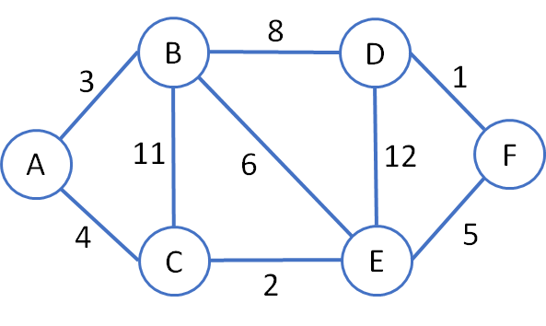

**1(c)** In accordance to the question **1(b)**, write down the lowest-cost path from A to F. (5 marks)

**Question 2 [50 marks]**

Given the graph *H* below:

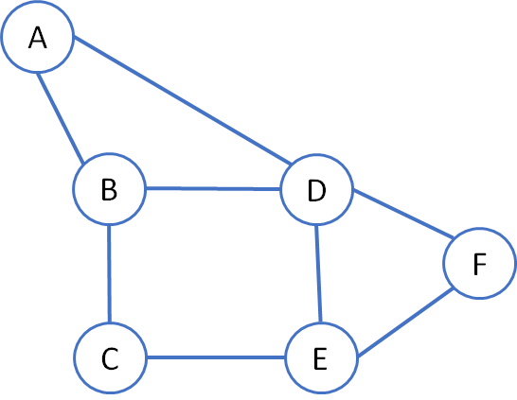

**2(a)** Determine the adjacency matrix of the graph *H*. (20 marks)

**2(b)** Does the graph *H* contains an Euler path? If yes, show such path. If not, add edge(s) to make the graph *H* contains an Euler path and show such path. (15 marks)

**2(b)** Add edge(s) to make the graph *H* to have an Euler circuit. List the vertices of the circuit in sequence of visit. (15 marks)

End of Quiz 2